Do you agree or disagree with this statement? |  |  | 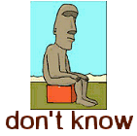 | Why?
- A parent will always love their child more than their child loves them.
- A child should always be grateful to her/his parents.
- A parent should love their children no matter what they do or what they say.
- A son/daughter should provide for his/her parents in their old age.
- The most important thing you can do in a family is accept faults and be prepared to forgive.
- There’s nothing bigger than the family.

